1. Login to google cloud

gcloud auth login

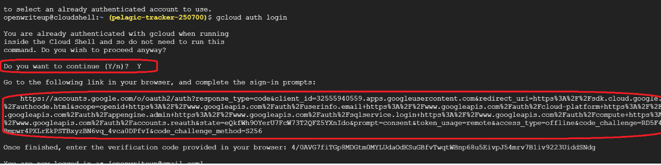

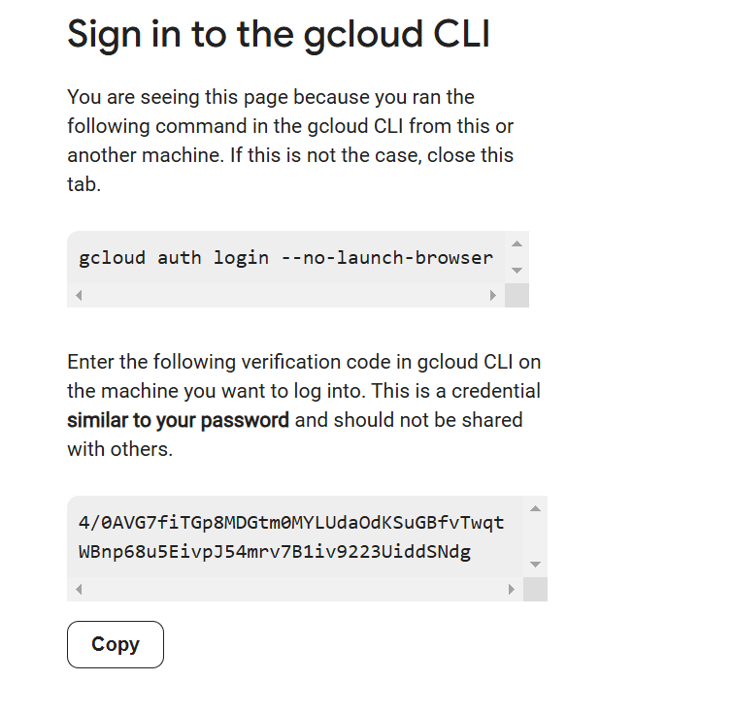

1. List the projects

gcloud projects list

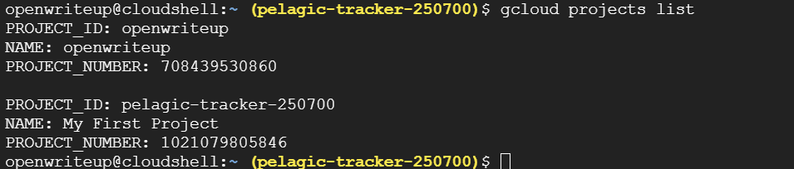

1. Set the project

gcloud config set project openwriteu

1. List iam roles

gcloud iam roles list

1. List service account

gcloud iam service-accounts list